**LAIKIPIA UNIVERSITY**

**SCHOOL OF SCIENCE AND APPLIED TECHNOLOGY**

**INDUSTRIAL ATTACHMENT REPORT**

**BY**

**N16/3/0561/017**

**EMILY JOKI WANYEKI**

**THIS REPORT HAS BEEN SUBMITTED IN PARTIAL FULFILMENT OF THE REQUIREMENTS FOR THE AWARD OF A DEGREE OF BACHELORS OF SCIENCE IN INFORMATION AND COMMUNICATION TECHNOLOGY AT LAIKIPIA UNIVERSITY.**

# DECLARATION

**Student’s Declaration**

I declare that the contents of this report are a true record of all the activities undertaken during my industrial attachment at the National Social Security Fund, Nyahururu branch.

Emily Njoki Wanyeki

Signature Date

**Organization Based Supervisor’s Declaration**

I confirm that this student undertook their attachment at the National Social Security Fund branch in Nyahururu under my supervision, and the informationrecorded in this report is a true representation of their experience in this office.

Wilson Maina Maritim,

Branch Manager,

National Social Security Fund Nyahururu.

Signature Date

# ACKNOWLEDGEMENT

This attachment has offered great lessons which could not be gained during the normal class environment. I had high time to interact with people experienced in the outside school environment and customers. This could not be effective if I worked on my own without support. First of all, I want to thank Almighty God for granting me the chance to be placed at the National social security fund. I thank HIM for his protection, favor and provision to my needs during the attachment period. For me to be alive today it is by his mercies. My special appreciation also goes to the Managing Trustee and the Branch manager Nyahururu Mr. Wilson. M. Maina for granting me the opportunity to work in the great corporate state and learn from the activities of National Social Security Fund. I also pass my appreciation to my supervisor Mr. for his support and guidance during the attachment. I extent my gratitude also to all other staffs at the Branch office; Madam Margaret Kariuki in Benefits Department/section, Mrs. Jane Ndurumo at the Accounts, Mr. Wesley the compliance officer, Mr. Evans kiptoo at the Registry, and Mr. James. They were very willing to offer me the recruitment at their expense of their valued time.

Finally, I pass my gratitude to my assessor Dr. Boaz Too for taking his time to visit me for evaluation and also his encouragement the day he visited the organization office. I thank the University administration for seeing it good to expose us to the field before completion of our course.

# DEDICATION

This attachment report is dedicated to my family, friends, colleagues and those who participated or assisted in any way during its undertaking for their support.

Thank you and God bless you all for your support and helpful contribution and guidance

# LIST OF FIGURES:

Figure 1.1: Geographical location………………………………………………………2

Figure 1.2: Organizational structure…………………………………………………….7

# ABBREVIATION AND ACRONYMS

**NSSF:** NATIONAL SOCIAL SECURITY FUND

**DMC:** DUPLICATE MEMBERSHIP CARD

**ICT:** INFORMATION COMMUNICTION AND TECHNOLOGY

**SF:** SECURITY FUND

**LPO:** LOCAL PURCHASE ORDER

**SSPAS:** SOCIAL SECURITY PENSION ADMINISTRATION SYSTEM

**SWOT:** STRENGTH WEAKNESSES, OPPORTUNITIES AND THREATS.

**RAM:** RANDOM ACCESS MEMORY.

**IP:** INTERNET PROTOCOL.

**PCs:** PERSONAL COMPUTERS.

**ISO:** INTERNATIONAL STANDARDS ORGANIZATION.

## DEFINITION OF TERMS

**Social security:** securing one’s future income security.

**The National Social Security Fund (N.S.S.F)**: A pension scheme for one’s old age

**Provident fund:** all self-employed and voluntary members registered with the fund

**Pension fund:** all persons above 18years of age and below the pensionable age of 60 years in the formal employment

# EXECUTIVE SUMMARY

This report is an inclusive experience in all the departments at the NSSF Nyahururu branch for a period of eleven weeks. The objectives of the industrial attachment are; to equip the student with relevant practical skills not taught in class, to enable students apply knowledge acquired in class to work environment, to enable a smooth transition between class and work environment among many others as explained later in this report. It also includes the mission statement of the whole pension fund, the vision, the mission and the core values as outlined in the organizational profile.

Organizational profile includes it’s; the geographical location, historical background, organization structure and the details of the departments I was attached to. I was attached to ICT department where the main activities I did during the attachment period were: devices preventive maintenance, networking, hub and switch configuration, ICT systems support, computer hardware repairs, packet tracing, printer configuration, Customized software installation and configuration among many other activities that are explained in details in this report. It also contains the duties and activities undertaken in the various departments, the analysis of learnt knowledge, applied interpersonal and communication skills and those gained.

It outlines the observation and critique of the organization relevance to experience

as well as a summary and conclusion section plus recommendations for university training and for the organization which according to my point of view could improve the overall running of activities in the organization.

Table of Contents

DECLARATION 2

SUPERVISOR’S DECLARATION: 2

ACKNOWLEDGEMENT 3

DEDICATION 4

LIST OF FIGURES: 5

ABBREVIATION AND ACRONYMS 6

DEFINITION OF TERMS 7

EXECUTIVE SUMMARY 8

1.0 CHAPTER ONE 12

1.1 BACKGROUND 12

1.1.1GEOGRAPHICAL LOCATION 13

1.2 NATIONAL SOCIAL SECURITY FUND HISTORICAL BACKGROUND 13

1.3 CORE FUNCTIONS 15

1.4 VISION. 15

1.6 CORE VALUES. 15

1.7 SWOT ANALYSIS 16

1.8 STRENGTHS. 16

1.9 WEAKNESSES 16

1.10 OPPORTUNITIES 17

1.11 THREATS 17

1.12 ORGANISATIONAL STRUCTURE 18

2.0 CHAPTER TWO. 19

2.1 ATTACHMENT EXPERIENCE. 19

2.1.1 General Orientation. 19

2.2 GENERAL ACTIVITES UNDERTAKEN. 19

2.2.1 IT DEPARTMENT. 19

Figure 2.1 CMOS chip. 20

Figure 2.2 Hard disk 20

Figure 2.3 Computer motherboard. 20

Figure 2.4 Computer RAM. 21

Figure 2.5 21

Figure 2.6 22

Figure 2.7 22

Figure 2.8 22

Figure 2.9 22

Figure 2.10 23

Figure 2.11 23

2.2.2 REGISTARATION. 25

2.2.3 REGISTRY 25

2.2.4 BENEFITS 25

2.2.5 COMPLIANCE 26

2.2.6 CASH OFFICE. 26

3.0 CHAPTER THREE. 27

3.1 MAIN OBJECTIVES OF THE TRAINING 27

3.2 ACHIEVEMENTS DURING THE ATTACHMENT 27

3.3 Analysis of learnt knowledge. 27

3.4 Analysis of Applied skills 28

3.5 A PROFILE OF SKILLS AND COMPETENCIES GAINED /ACQUIRED 29

4.0 CHAPTER FOUR. 31

4.1 OBSERVATIONS AND CRITIQUES 31

4.1.1 POSITIVE OBSERVATIONS 31

4.2 CRITIQUE ABOUT THE ORGANIZATION 32

4.3 CHALLENGES ENCOUNTERED DURING THE ATTACHMENT PROCESS. 32

4.4MITIGATION TO THE CHALLENGES FACED 33

5.0 CHAPTER FIVE. 34

5.1 SUMMARY, RECOMMENDATIONS AND CONCLUSION 34

5.2 RECOMMENDATIONS TO THE ORGANIZATION 34

5.3 RECOMMENDATIONS TO THE UNIVERSITY. 35

5.4 CONCLUSION 35

REFERENCES 36

# 1.0 CHAPTER ONE

# 1.1 BACKGROUND

This report is a summary of the activities carried out and general industrial training experience gained for the 11 weeks dated from 4TH October 2021 to 16th July 2021.

The industrial attachment was carried out at the NSSF Nyahururu branch a subsidiary branch of the National Social Security Fund which covers the whole Laikipia and Nyanadarua county employers and employees as well as voluntary members registered with the fund.

# 1.1.1GEOGRAPHICAL LOCATION

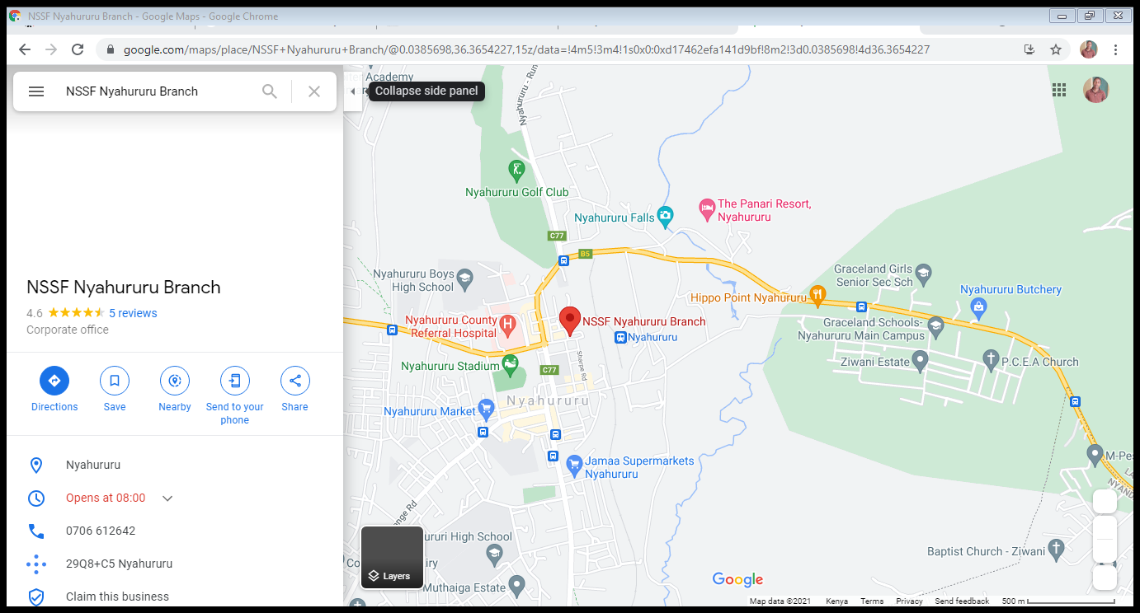

# 1.2 NATIONAL SOCIAL SECURITY FUND HISTORICAL BACKGROUND

The national social security fund can be traced back in 1995 by an act of parliament (NSSF Act Cap 258 laws of Kenya). It began operation in 1965 as a department within the ministry of labor and was eventually transformed into a state corporation in 1968. Currently the fund is run by a tripartite Board of Trustees with a presentation from employers, employees and government. Under the National Social Security Fund Act No. 45 of 2013 both employed and the self-employed and their dependents qualify as contributing members. The act (law) on pension requires all Kenyans that are above 18 years of age to register to the program.

The Board of Trustees is composed of worker’s representatives through the Central Organization of Trade Unions. Employers through the federation of Kenya Employers that the Board of Trustees accommodates the views and aspirations of the three social partners in policy formulation and running of the organization.

# ****1.3 CORE FUNCTIONS****

The core functions of the National Social Security Fund are: -

1. Establishing quality objectives at the beginning of every financial year based on the corporate strategic plan which shall be monitored and reviewed on a quarterly and annual basis.
2. Seeking to understand and satisfy the needs and expectation of customers.
3. Ensuring all activities are aligned to NSSF Act No. 45 of 2013.
4. Embracing best practice, innovation and appropriate technology in all operations.
5. Having committed trustees and staff performing their roles and responsibilities and integrity and accountability.

# 1.4 VISION.

To be a trusted center of excellence in the provision of social security.

**1.5 MISSION.**

To provide social security to members through enhanced coverage, efficient registration and collections, prudent fund management, competitive benefits and exemplary governance.

# 1.6 CORE VALUES.

To attain the vision and mission and build its own culture, the ministry has identified the following core values:

* Customer focus – To understand what the customer need by responding to their needs no matter their background.
* Integrity- The fund will ensure that all the staff complies with the public officers’ ethics Act.
* Innovation- Ensure every customer meets his/her needs and improving the system.
* Accountability- Must be accountable in your work.
* Team work- The organization meets its need by assisting each other through working together as one.

# 1.7 SWOT ANALYSIS

SWOT is an acronym for strength, weaknesses opportunities and threats which was carried out to identify the ministry’s Strengths and weaknesses (Internal analysis) in relation to external opportunities and threats (external analysis).

SWOT analysis was done so as to identify and take corrective measures in order to enable the ministry to stay on course in as far as services delivery is concerned.

# 1.8 STRENGTHS.

The strength of the ministry lies in:

1. Qualified personnel

The ministry has qualified personnel with specialized training in collection, safekeeping responsible investment and distribution of retirement funds of employees in both the formal and informal sectors of the Kenyan economy.

1. Good working relationships with customers

The ministry has established good working relationships with key customers in the registrations, accounting, and benefits sector.

1. Existence of a legal framework governing the staffs

The NSSF Act (Cap No.45 of 2013) and maritime zones Act (Cap 371) provides a legal framework for management and development of social security

# WEAKNESSES

1. Inadequate number of technical staff

The number of qualified personnel is quite inadequate, leading to heavy workloads thereby affecting the work flow.

1. **I**nadequate operational facilities

The ministry faces an acute shortage of operational facilities and equipment that includes vehicles, information and communication Technology and equipped offices.

The increasingly growing regional and global integrations offer expanded the opportunities of people registering.

# 1.10 OPPORTUNITIES

The Growing Regional and International organization.

# 1.11 THREATS

NSSF fund bill pointing out that it will kill the private pension industry if not addressed.

NSSF law makes it difficult for employers to opt for other private pension schemes for their staff.

## 1.12 ORGANISATIONAL STRUCTURE

Organizational Structure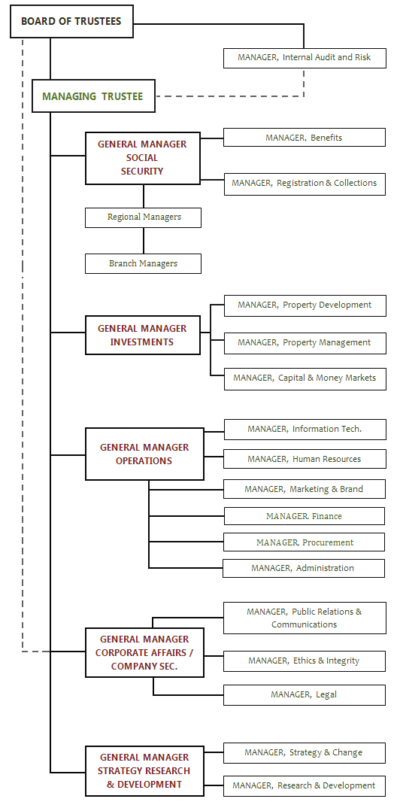

Figure 1.2 organizational structure

# 2.0 CHAPTER TWO.

## 2.1 ATTACHMENT EXPERIENCE.

## 2.1.1 General Orientation.

My industrial attachment began with a mandatory orientation to KCRH rules and regulations. I was taken through various departments’ functions, physical location and the ICT systems in them.

I was informed about the following issues which every person working at KCRH must adhere to:

1. **Working hours:** 8am to 5pm from Monday to Friday except on public holidays and weekends for a period of 3 months.
2. **Dressing code:** Official clothes from Monday to Friday.
3. **Safety rules**: safety rules to adhere to always.

To wrap up my orientation I was issued with the attachment time plan which indicated what I was supposed to learn every week, all activities I was supposed to carry out each week as well as offering ICT support to users at their departments to ensure that the Hospital IT systems ran smoothly and efficiently.

## 2.2 GENERAL ACTIVITES UNDERTAKEN.

These are the general activities I carried out on daily basis to ensure smooth running of activities in the branch.

### 2.2.1 IT DEPARTMENT.

As a computer science student, I was majorly involved in this department.

The activities involved in this department include;

1. Computer hardware maintenance.

I also learnt how to disassemble both desktops and laptops, to install components like hard disk, RAM, CMOS battery, motherboard replacements, RAM upgrading, and assemble them back and test whether they are working correctly. I was informed of the safety precautions I should observe to avoid risk of electric shock and damaging the computer components as they are sensitive.

## **Figure 2.1 Hard disk**

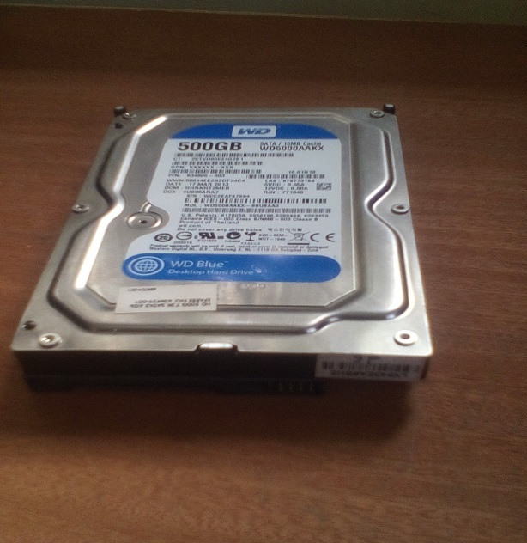

## Figure 2.2 Computer motherboard.

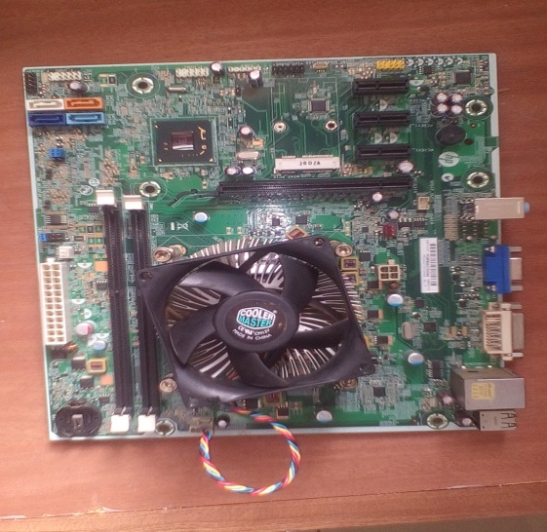

## Figure 2.4 Computer RAM.

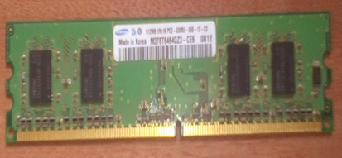

1. Installing and updating various software. This involved the SSPASSAPP software which we used in various activities including registration of members and employees, capturing benefit claim information, receipting among other activities, EDMS software which we used to upload claim filled form for claim processing which is a process involving various people with different roles in the region.
2. Networking which involved creating and using computer networks with respect to hardware, protocols and software, including wired and wireless technology and making sure it’s secure and safe. Some of the activities include the following; Ethernet cable crimping, network pinging and packet tracing, troubleshooting computer failure to connect to network, module termination, cable management and identification of loose cables in the network and intranet configuration.

Procedure in making a standard Ethernet Cable

1. Cut into the plastic sheath about 1 inch (2.5cm) from the end of the cut cable using the cutter.

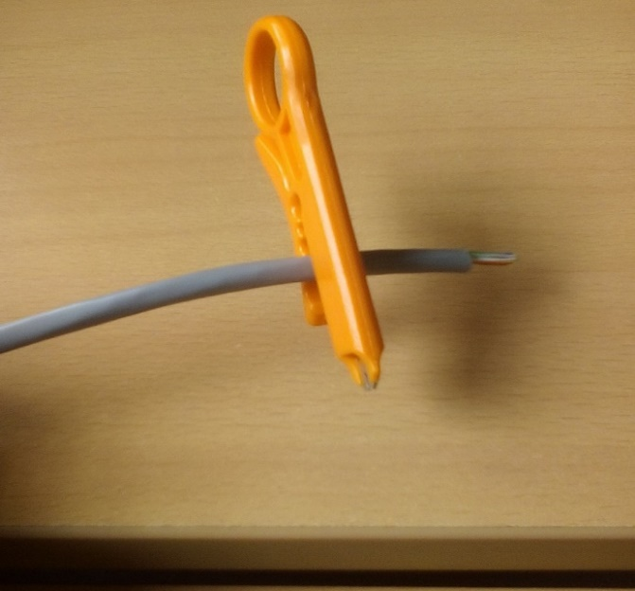

## Figure 2.5

1. Unwind and pair the similar colors.

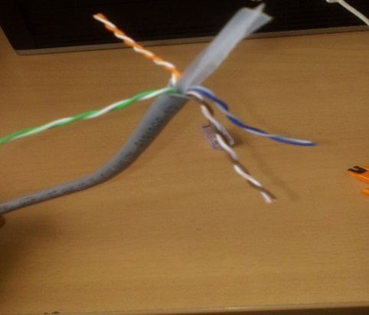

## Figure 2.6

1. Pinch the wires between your fingers and straighten them out as shown. The color order is important to get correct.

## Figure 2.7



## Figure 2.8

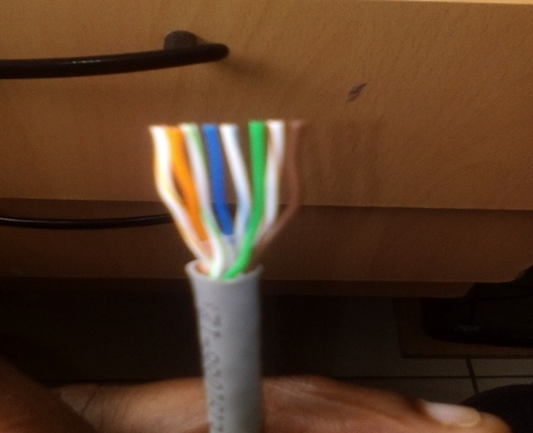

1. Use a cutter to make a straight cut across the 8 wires to shorten them to 1/2 Inch (1.3 cm) from the cut sleeve to the end of the wires.

## Figure 2.9

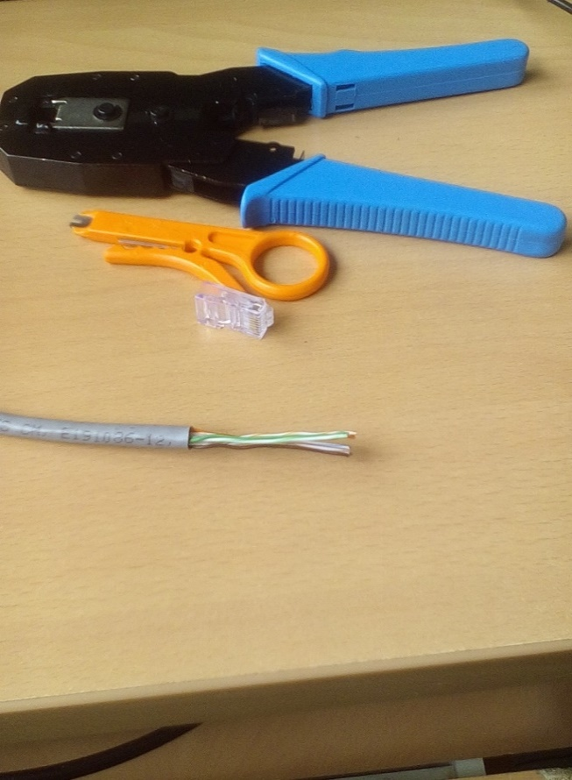

## Figure 2.10



1. Carefully push all 8 unstripped colored wires into the RJ 45 connector.

Confirm a view from the top all the wires are all the way in There are no short wire

## Figure 2.11

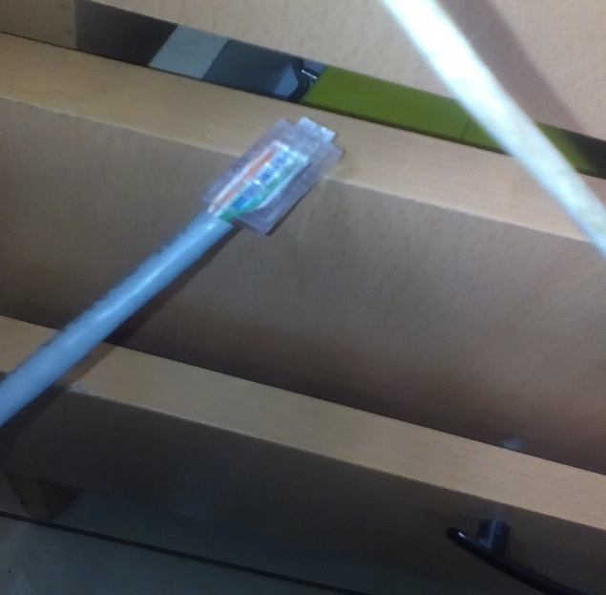

Module Termination Procedure

* Start by crimping the RJ-45’s on the cable with the right color combination i.e. White orange, orange, white blue, green, white green, blue, white brown, brown consecutively from left to right.
* Connect the wire from the riser room and onto the wall socket where one would be able to plug in from the desktop.
* Terminate the connection at the patch panel and then connect one of the ports in the patch panel to the switch.

1. Technical support.
2. Installing new hardware and devices to support the activities at NSSF.
3. Cleaning of computer CPUs.

The procedure for performing cleaning and preventive maintenance in computers includes the following:

* Switch off the device and disconnect power supply for desktop or remove battery for laptop.
* Unscrew them to remove Hard disk and RAM.
* Moisten a cotton cloth with cleansing agent and wipe the screen.
* Use a dust blower and blow the dust particles with low power supply to avoid damaging motherboard connections.
* Clean keyboard by brushing it using a brush and moistened with small amount of cleaning agent.
* Replace hard disk, RAM and assemble your desktop or laptop.

Power on your machine to and ensure it is working correctly

1. Training staff how to use new software systems.
2. Storing and protecting the organization’s data and information.
3. Implementation of ICT policies and strategies.

A driver is a program that operates or controls a particular type of device that is attached to a computer, such as a modem, network adapter, or printer and enables the device to communicate with the operating system. I was introduced to various drivers used in the organization, how they are configured and I was able to install and update drivers. I was later assigned the following tasks:

* Reinstallation of failed drivers which caused the problems to the computers like failing to connect to network, no sound, poor screen brightness, poor screen resolution, USB port failure and many others.
* Updating current drivers in computers to ensure they are up to date.
* Manually installing missing drivers to computers which didn’t install some drivers automatically.
* Installing HP printer drivers to computers to enable users of those machines to print their work and documents from their computers

### 2.2.2 REGISTARATION.

**Registration of Employers –** Upon acquiring certificate of registration from the registrar of business it is a law that one registers his employees with the fund. This is done by the employer filing a SF01 form. Upon filling, the data is captured in the SSPAS system and the registration takes less than 20 minutes as outlined in the service charter. This is inclusive of societies, SACCOs, public institutions, parastatals and corporations.

**Registration of employees -**Employees are registered under their employer.

**Registration of voluntary members** – A member can register with the provident fund that requires him/her to voluntarily contribute a minimum of Ksh.200 per month or Ksh. 4,800.00 per annum. Registration is free upon initial contribution of Ksh.200 to the members account. The process takes 15 minutes and the member is required to be captured fingerprints.

**Issuing of Statement Accounts –**With a member number, Identity Card or Employers number, I could issue the members or the employer with the statement consisting of all the contributions paid.

**Issuance of Duplicate Membership Cards –** DMC are issued in case of misplacement at a fee of Ksh.200.00

### 2.2.3 REGISTRY

Filing, retrieval of files, receiving of mails and sending them, custody of the post office key is all in this department. I ensured that all documents were well filed and the places stored at the right places in the back-filers.

### 2.2.4 BENEFITS

As outlined in the CAP 45 of 2013, and in liaison with the benefits officer, I ensured the payment of the following types of benefits upon incoming protocol request.

This was through helping members fill the EFT and authority forms, take their fingerprints, open for them files and send them to the headquarters, capture data in the SSPAS and trace the movement of their files and money up to when the members accounts are credited.

The type of benefits offered include:

1. Age Benefit – Payable to a member who has retired from a gainful employment at the age of 55 years.
2. Withdrawal benefits- payable to a member upon an early retirement from a gainful employment at the age of 50 years.
3. Survivor’s Benefit – Payable to the dependents upon the death of the member who had contributed at least 36 installments before the time of death.
4. Invalidity Benefit – Payable to a member who suffers physical or mental disability of a permanent, total incapacitated as certified by a medical board.
5. Emigration Benefit – Payable to a member emigrating from Kenya to a country which is not a member state of the East African Community, without any intention of returning to reside in Kenya.
6. Funeral grant – payable to the dependents upon death of a member who had contributed at least 36 months and before elapse of 90 days from the date of death. Currently the grants stand at Ksh.2500

### 2.2.5 COMPLIANCE

In the department that involves establishing the state of compliance of the employers I worked closely with the compliance officer to perfume the following duties:

* Calculation of arrears and penalties accrued from skipped monthly contributions.
* Assessment of the past employers’ contributions
* Penalty payment monitoring
* Inspection of records requested from the employers
* Writing of penalty and arrears demand letters
* Issuance of employers provisional statements

### 2.2.6 CASH OFFICE.

Towards the end of the ten weeks’ attachment period, I got involved at the cash office. The main activities I carried out in the cash office include;

1. Receiving cheques from employers and receipting them.
2. Receiving voluntary contributions from members and receipting them.
3. Generating E-Slips for employers each with a unique payment number for receipting.
4. Generating daily transaction report.
5. Banking.

# 3.0 CHAPTER THREE.

**EVALUATION OF THE ATTACHMENT TRAINING**

## 3.1 MAIN OBJECTIVES OF THE TRAINING

* To develop interest in the career am undertaking.
* To develop my understanding of ICT work ethics, employment demands, responsibilities and opportunities available in the field of IT.
* To have an improved appreciation of the ICT profession and hence better work ethics: By working in a busy ICT environment I am expecting to have a good understanding of the ICT concepts and understand how they are applied to solve the daily problems facing our society.
* To get a good understanding of skills required in the IT job market, realize my potential and choose the career I want to major in after my course e.g. Networking, Network security, Database administration, System administrator, Project management etc.
* To acquire new knowledge and skills from the organization department attached to, through interaction with ICT department staff and technicians.
* To be acquainted with the expectations of working in a highly competitive surrounding in service delivery to the public.
* To be equipped with practical skills that may not be taught in class e.g interpersonal and communication skills
* To establish networking with the cooperate world that makes the transition from school smooth through contacts relevance for job placements
* To provide a platform to apply theoretical work on practical basis.

## 3.2 ACHIEVEMENTS DURING THE ATTACHMENT

With regard to the objectives of the training, it has been a success and all objectives have been met at a great percentage

## 3.3 Analysis of learnt knowledge.

This includes both the theoretical and practical knowledge I gained through the industrial attachment process.

Firstly, the exposure and experience I gained in the organization has helped me to the general operation of the fund and how various departments interrelate to bring out successful results has proved that team work and good human relation is a fundamental tool in any work environment.

The exposure to the general operation of the fund and how various departments interrelate to bring out successful results has proved that team work and good human relation is a fundamental tool in any work environment.

Data entry, as one of the main activities within the fund has equipped me with valuable skills to effectively capture data and manage it.

During the e-services and e-slip generation I was exposed to employees’ gross pays which helped me to gain skills in data security and management and secrecy in maintaining the office secrets as one of the work ethics.

Dealing with customers of every kind, stubborn and good boosted my communication skills by seeking to apply the best way in mitigating complains and compliments from them. Different complains lodged at the reception desks helped me learn how all departments are interrelated. The interaction with the staff and departmental heads gave me an ideal platform for me to practice office etiquette.

In the process of penalty monitoring, drafting letters to employers to demand for the dues has enabled me gain the knowledge of better written communication skills. Penalty calculation has also equipped me to mathematical formulas and calculations.

The art of accountability, reliability, dependability, self-start and order in the workplace was impacted on me.

## 3.4 Analysis of Applied skills

It is a great honor offered to me by the NSSF Nyahururu branch to employ the skills learnt in class to the real dynamic world of service delivery to the public.

I am humbled to have been able to take this valuable opportunity to explore and experience new dimension of working in an organization. The attachment gave me an ideal environment and a chance of applying the learnt knowledge and skills in class at the workplace. Through the exposure to the wide application of IT infrastructure at NSSF, I was able to interaction with customers, I was able to employ and improve my communication and data science skills and contribute my ideas and useful insights to the customers and the branch too.

The use of SSPASSAP, cleaning computer CPUs, connecting printers to the network, repairing malfunctioning printers, replacing Ethernet cables, installing and updating software and e-slip generation helped me employ the learnt IT skills in the workplace.

## 3.5 A PROFILE OF SKILLS AND COMPETENCIES GAINED /ACQUIRED

**Advanced Skills in computer architecture assembly, disassembly** and troubleshooting problems in computer hardware.

**Skills in Networking, routing and switch configuration.** Through continuous networking activities carried out, I learnt and acquired many skills which will be key in pursuing my networking ambitions.

**Knowledge in printers, Print Server** and domain.

**Skills in Microsoft Exchange Server**, basic outlook operations, outlook mails configuration and troubleshooting.

**Resolving user login conflicts and trust relationships in the domain**

**Skills in ICT systems administration:** I acquired knowledge and skills in INSIGHT administration, Print Server administration and Active directory administration by having all the administrator rights and privileges.

**Knowledge in trust vendors, licensing technologies and secure computing:** Which is very essential in IT with the current rise in cybercrime.

**INTERPERSONAL SKILLS.**

**Time management**

Timely execution of assignments is skill for any professional. Arrival and departure time should also be taken seriously for any individual willing to offer the best services in service delivery. Things are not good when done from start to end but also when timely done.

**Communication skills**

Listening is one of the core parts of a productive conversation. Interaction with departmental heads, the branch manager and all staff has equipped me with courtesy and etiquette both my verbal and written forms. Interaction with customers at the reception and my fellow attaches’ has boosted my ability to accept diversity.

**Team work**

I came to appreciate the value of belonging to a team. This attachment enabled me to acquire the knowledge of team work which enabled me to appreciate the value of listening and accommodating people’s views however much diversity.

About Human Relation; I was able to improve my relations with the staff, the attitude developed towards teamwork improved. Teamwork made work easier in communication with the staff for better ideas were made regularly. Teamwork improves morale and aids in improving the organization’s behavior and image.

**Value of unity of command**

The Ministry being a system, made me appreciates the management process of coordination that defines how and when various subsystems of a system should coordinate as they carry out their different functions in pursuit of the common objective of the organization. I also learnt practically how the different departments work in collaboration with the procurement department.

**Organizing**

I also came to learn the essence of orderliness because all the departments and more so the procurement department, being the custodian of all the items in the stores needed to ensure that things are kept in an organized and orderly manner for ease of retrieval, stock taking inspection among other things. I also learnt that it is very prudent for the files to be orderly and neatly kept for ease of retrieval and referencing. Again, the files should be also orderly and neatly kept in their respective cabinets and the cabinets should always be locked to avoid unauthorized persons having access to the files.

# 4.0 CHAPTER FOUR.

## 4.1 OBSERVATIONS AND CRITIQUES

With active engagement in an office that has free and timely flow of information across all departments and staff, positive and negative observations are equally evident. First, I highly recommend the professionalism employed by the competent staff working in the branch.

### 4.1.1 POSITIVE OBSERVATIONS

1. **Results driven team**

By the end of the financial year the team has been able to meet and exceed the set targets for the registration and collections within the branch. There has also been a good rating in the ombudsman report of 89% and almost all risks identified and are being worked on.

1. **Amiable staff**

The most accommodative staff one can ever get making the interns feel the sense of belonging and hence boosting their morale to work. They are also accommodative to the customer’s ad this has given the branch a very good score of 89% in the ombudsman report

1. **Coordination and teamwork**

From the registration, the registry, compliance and benefits departments as well as collections

there is a clear coordination that motivates the staff in the branch. This has boosted the efficiency resulting to use of less time than that indicated in the service charter

1. **Ability to impact knowledge**

A competent and accommodative team of staff that offers the best platform to learn. With great knowledge and willingness to offer it to others is a great thing.

1. **Ability to comply to legal and organizational decisions**

The fund has complied to almost all legal and organizational decisions presented to them by the headquarters and the constitution of Kenya

## 4.2 CRITIQUE ABOUT THE ORGANIZATION

Understaffing has been the greatest menace in the branch for long which has never been acted upon even after addressing it to the regional and national office. This makes one staff multitask which generally is an epitome of inefficiency. The branch has no accountant, has only one compliance officer for the three zones and only one registration officer which tends to be a huge workload.

Network surges which has not be solved for months is now lowering the productivity and increasing the customer dissatisfaction rates.

Other than printed copies of information, there has been low education in the region about the fund due to lack of public forum to educate the public. This has led to many people in the region not understanding the services provided by the fund.

## 4.3 CHALLENGES ENCOUNTERED DURING THE ATTACHMENT PROCESS.

In every process, challenges are inevitable and same has been evident. One, financial constraints. The fund does not provide a stipend or any allowance and being a student, it has been a struggle to make ends meet since the attachment was far away from home.

The organization is located on a highland and there have been adverse weather conditions, at times extreme cold which has affected my heath hence lowering the performance which otherwise would have been higher.

Inadequate staffing has contributed to me having to multi task especially having more than one staff allocate me a duty almost at the same time. This has increased the time frame used to complete assigned tasks assigned which makes me feel ineffective.

## 4.4MITIGATION TO THE CHALLENGES FACED

My parents and relatives have been with me for any support I required during the training. I have also made sacrifices like skipping lunch in some days and saving where possible.

Bearing in mind that taking peoples finger prints was a quite a challenge, I did several practices with my fellows who were under attachment program like I and thus I perfected the skill. I am really grateful to them for the support during the attachment program.

Through assignments allocation at the same time by different staffs I have been trained to change priories to attend most emergent and important tasks at any time. It has also trained me how to respond to positive criticism and how to effectively manage time.

# 5.0 CHAPTER FIVE.

## 5.1 SUMMARY, RECOMMENDATIONS AND CONCLUSION

This report contains details of my practical experience, observations and skills learned during my industrial attachment at NSSF Nyahururu Branch. It is a compulsory requirement for all undergraduate students to attend external attachment before graduation. It helps the students acquire practical experiences in addition to the skills learned in the course of study at the university. In addition, it exposes the students to the real world of work and challenges in the field. This prepares them psychologically toward their future plans and dreams and also their career.

The report is based on my experiences and observation information gathered during the attachment period. It outlines the organizational structure of the attaching firm, brief history of the Fund, the mission, vision, core values and the details of the departments attached.

A lot of my work was under compliance department during my attachment but I also operated at other departments during the attachment. In the report I have given analyses of the knowledge acquired in each department I operated under, skills gained and observations during the attachment period.

I have also included the challenges faced during the attachment and recommendations both to the university and to the attaching firm which according to my view they will benefit the university to better the program and the organizations to better its operations in future.

At the end of the report I have included the conclusion section and the Appendix giving details of any abbreviations used in writing the report.

## 5.2 RECOMMENDATIONS TO THE ORGANIZATION

1. The branch to use biometric system to take fingerprints instead of the papers for the purpose of registration and benefits payments. However, the branch can also have a fingerprint expert to analyses the required fingerprint forms other than sending them to the headquarters which takes time.
2. The IT department to upgrade the SSPAS system so that it can enable a fortnight notification to the compliance officer the state of compliance of employers after demand letters, inspection reports and notice of prosecution letters have been sent to them and help the officer act accordingly
3. The NSSF national office to decentralize the way they give their jobs to the regions or branches to avoid shortage of staff in the branches at any time.
4. The region to have several IT technicians who will constantly deal with network issues, machine maintenance and upgrades and data security.
5. The organization to regularly have public forums to educate the public about the fund, probably once, twice or three times in a financial year. This will also help those who are illiterate and give the society a sense of belonging.
6. The organization to plan for a Corporate social responsibility function that will help the adjacent society especially by the fact that it has been long since one was carried out.

## 5.3 RECOMMENDATIONS TO THE UNIVERSITY.

1. The attachment to be undertaken several times in between the curriculum for the students to have a chance to apply what they learn in class regularly before completion of their final year. This is because the student will learn and digest more.
2. The school should maintain a long-lasting relationship with vast organizations so that it creates a mutual link between the students and the attaching firms, this will make it possible for future reabsorption of more students from the school to the companies. Hence lessen the time and resources required for students to secure a good attaching firm.

## CONCLUSION

For an undergraduate student, industrial attachment is one of the most crucial thing in the learning process as it exposes the student to the real dynamic world. It exposes one to the life challenges and empowers the student to come up with solutions to possible challenges which boost their performance.

In most sincere way, I appreciate NSSF management and staff for the opportunity they accorded me in the organization to pursue my industrial attachment which has helped me in a great way boost my skills especially accountability and teamwork.

I also appreciate the school of mathematics for providing for me a supervisor to evaluate my performance in the organization.

I hope I played a role in the realization of organizational objectives and goals through my learning process.

# REFERENCES

* NSSF GUIDE BOOK­- ISO9001;2015 CERTIFIED
* https://www.nssf.or.ke/?wpdmact=process&did=MjEuaG90bGluaw